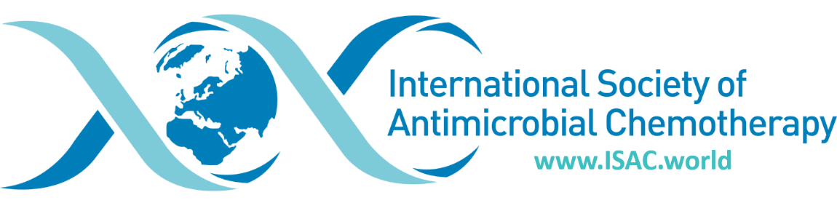

HUMA Awardees and Lecture Titles

2024 – Gunnar Kahlmeter
The quirks of the EUCAST susceptibility testing system

2022 – Robin Patel
Microbial Theranostics – A Resistance Combatting Strategy

2019 – John Turnidge

In Vitro Veritas - Susceptibility Testing in the 21st Century.

2017 – Karen Bush, USA
Beta-lactamases as we see them today

2015 – Alastair Geddes, UK
ICAAC / ICC 1965 to 2015: 50 years of Antibiotic Development

2013 – Keiichi Hiramatsu, Japan
Nature’s way to resolve antibiotic resistance.

2011 – Stuart Levy, USA
Antibiotic resistance: back to the bigger circle

2009 – Allan R. Ronald, Canada
Think globally; act globally

2007 – Satoshi Omura, Japan
Discovery of useful microbial metabolites with specific biological targets

2005 - Calvin M. Kunin, USA
Antibiotic usage: historical perseptives and challenges

2003 - William A. Craig, USA
Antimicrobial pharmacodynamics: rationale for optimising therapy and defining resistance.

2001 - Erik De Clerq, Belgium
An odyssey in antiviral chemotherapy

1999 - Richard Sykes, UK
Towards the magic bullet

1997 - J. David Williams, UK
New concepts and ideas in antimicrobial chemotherapy

1995 - Patrice Courvalin, France
Impact of molecular biology on antibiotic susceptibility testing and therapy

1993 - George K. Daikos, Greece
Anthopos and medical progress

1991 - George N. Rolinson, UK
History and current position of beta-lactam antibiotics

1989 - Ryochi Fujii, Japan
Chemotherapy in Japan – dawn and development

1985 - Piero Sensi, Italy
Rifampicin – twenty years after

1985 – Emil Frei III, USA
Curative cancer chemotherapy: evolving strategies

1983 – Edward P Abrahan, UK
Aspects of the biosynthesis of beta-lactam antibiotics

1981 – Susumu Mitsuhashi, Japan
Drug resistance plasmids

1979 – Mario Ghione, Italy

